**User Manual to Navigate Sex and Age Detection:**

1. **Step 1, Install Necessary Libraries**
   1. **Through Terminal**

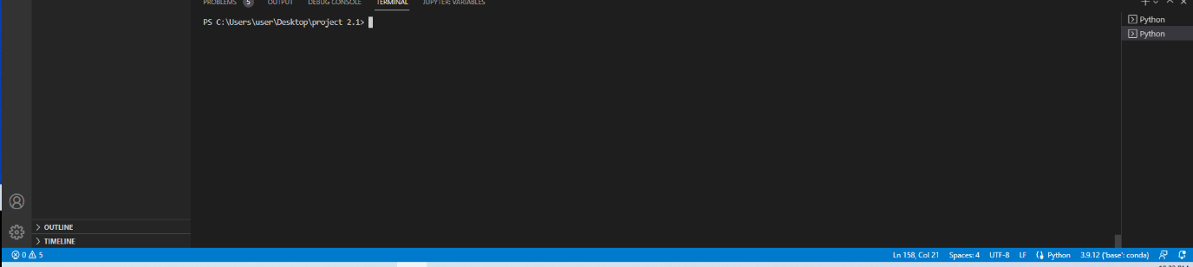

By Navigating to this panel and inserting the following lines of code you will be able to install the necessary libraries needed to run the code:

Pip install tensorflow, pip install opencv-python, pip install numpy, pip install matplotlib, pip install streamlit, pip install pandas, pip install requests

* 1. **Through Anaconda**

Download the Anaconda Navigator Here:

<https://www.anaconda.com/products/distribution>

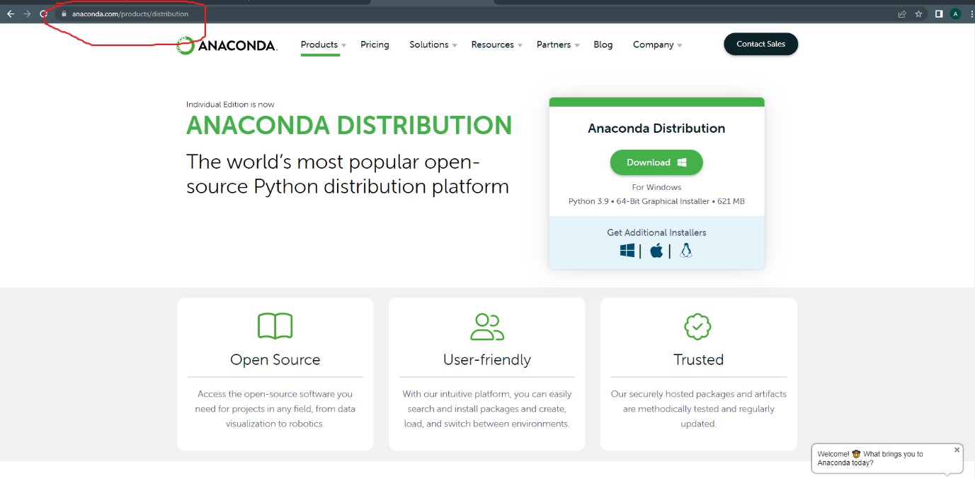

Click Environments then Click the top left drop down which says “not installed”

Next, in the top right corner search the packages which were mentioned previously and tick the box on the left and click apply in the bottom right to install.

1. **Step 2, File Location, Additional Folders and Dataset:**

Install the files on to your computer under a folder of your liking. Within the folder no additional files need to be created and furthermore the program can be utilised with my pretrained model which the folder already contains, however, if you would like to train the model yourself, the dataset from Kaggle must be downloaded using this url:

<https://www.kaggle.com/datasets/jessicali9530/celeba-dataset?resource=download>

1. **Step 3: Create_Subset_CSV.py**

In order to utilise the model training the list attribute celebA text will need to be converted to CSV, therefore this should be the first program run.

1. **Model Training**

In order to personally train the model, google collaboration is required due to the size of the file. By converting the .py file to. ipynb file and uploading it to google collaboration with the data set uploaded to google drive, with a couple extra lines of code which you can copy and paste below at the start of the file, you will be able to train your own dataset.

from google.colab import drive

drive.mount('/content/drive')

!unzip "/content/drive/MyDrive/CelebA.zip" #unziping the dataset

!unzip -q "/content/CelebA/Img/img_align_celeba.zip" -d "/content/CelebA/Img/" #unzipping the images

df = pd.read_csv("/content/drive/MyDrive/subset.csv")# reading the subset csv file using pandas library

#(df.head())

1. Step 5) App File:

To run this file, type the following into the terminal “streamlit run app.py”, once this has been typed, you will be redirected to a streamlit page where you will be able to upload images ready for detection.